Board Recruitment Pack
Community Enterprise
November 2024




The Opportunity
Community Enterprise is at a period of growth and change. We are extending the work we do into new areas and are consolidating and growing key teams including our digital work and branding and campaigning activity. We are on a sound footing, with excellent reach strategically and practically across Scotland and beyond.
To help us navigate that change and lead us into a vibrant future where can make a significant difference to the people and communities of Scotland, we are looking to further strengthen our board. Our priorities are to bring in enhanced skills in digital, branding and marketing, and finance. If you feel you can be part of the next phase of our development, we’d love to hear from you.

About Community Enterprise
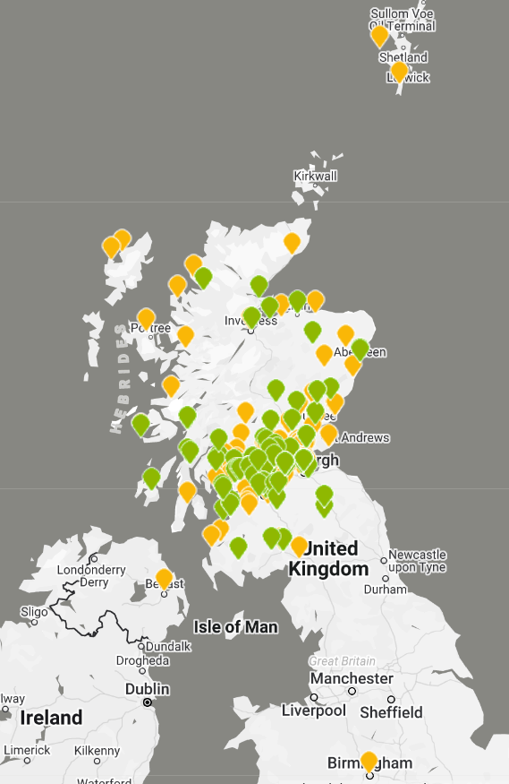
The Difference We Make
Lots of case studies can be seen on our website and the recent impact report can be seen here.
- 90% of our partners and stakeholders say that we deliver social impact a lot or quite a lot.
- 92% of clients would recommend Community Enterprise to other organisations.
- A significant 34% of respondents had worked with Community Enterprise for over 10 years indicating the validity of its value of “relationship”.
“There are few organisations that I have come across from around the UK as effective as Community Enterprise in supporting people to improve their places and their lives.” Firth Heritage
“A consultant will borrow your watch, and then sell it back to you! This wasn’t Community Enterprise, they have great integrity and you never feel you’re on-the-meter, they really want to help and want you to succeed.” King's Arms
Broader Context
Community Enterprise has been established for over 35 years and is one of Scotland’s leading social enterprise and community development consultancies and support providers. We provide support to third sector groups across Scotland and work with communities to build and sustain projects for the benefit of local people.
We have an expert team of 27 consultants and support staff and around 20 accredited associates with a range of experience in the private, voluntary and public sectors. We take pride in the high quality of support we offer. We work with around 500 clients a year and build up close, and often long term, coaching relationships to help implement plans.
We are a social enterprise ourselves. 100% of our profits are re-invested in supporting the further growth and development of voluntary and community organisations. To do this we earn income from consultancy services.
We are involved in various national contracts, including Just Enterprise, the government-funded social enterprise development programme. We are on the HIE Support for Communities framework and run a national capacity-building programme called Accelerate. We are on the framework to support Community Ownership Fund bids for DTAS and the Architectural Heritage Fund. We are on the support framework for the National Lottery Heritage Fund and are contracted by various funders to deliver business support to awardees.
Our core work, however, is with community based organisations rooted in a geographical community seeking to create sustainable development and regeneration – our strapline is ‘helping people make good things happen’.
Our Services
Our focus is on developing sustainable communities through resilience using techniques including social enterprise, innovative fundraising and community empowerment. We have developed four cross-fertilising divisions.
The Group’s Services and Divisions
We have developed four integrated divisions. As a summary:
- Our development team develops enterprise, communities and organisations including strategic thinking, market research, business planning, evaluations, organisational reviews, community plans and investment readiness.
Our over-arching website has information about all our divisions, but this is a link directly to the work of the development team.
- We operate the first and biggest social enterprise, strategic marketing and creative design and branding agency, called BOLD. Its services include branding, design and print, web design and build and creative marketing strategy. Bold Studio - Community Enterprise
- We deliver a social enterprise digital agency, soon to be launched as Breeze Digital. This will support the practical digitization of the sector from digital strategy to digital service design Breeze - Community Enterprise
- We have a research specific arm delivering pieces of work that respond to the big issues facing our sector Research and Thinking - Community Enterprise
- We are a strategic part of the sustainable third sector and provide strength and capacity to the sector. We were founding members of Social Enterprise Scotland and have a place on its Board of Directors. We are founding subscribers of the Voluntary Code for Social Enterprise and members of various national networks. We currently design and manage the social enterprise support map and organise workshops and training and have a fast evolving research arm.
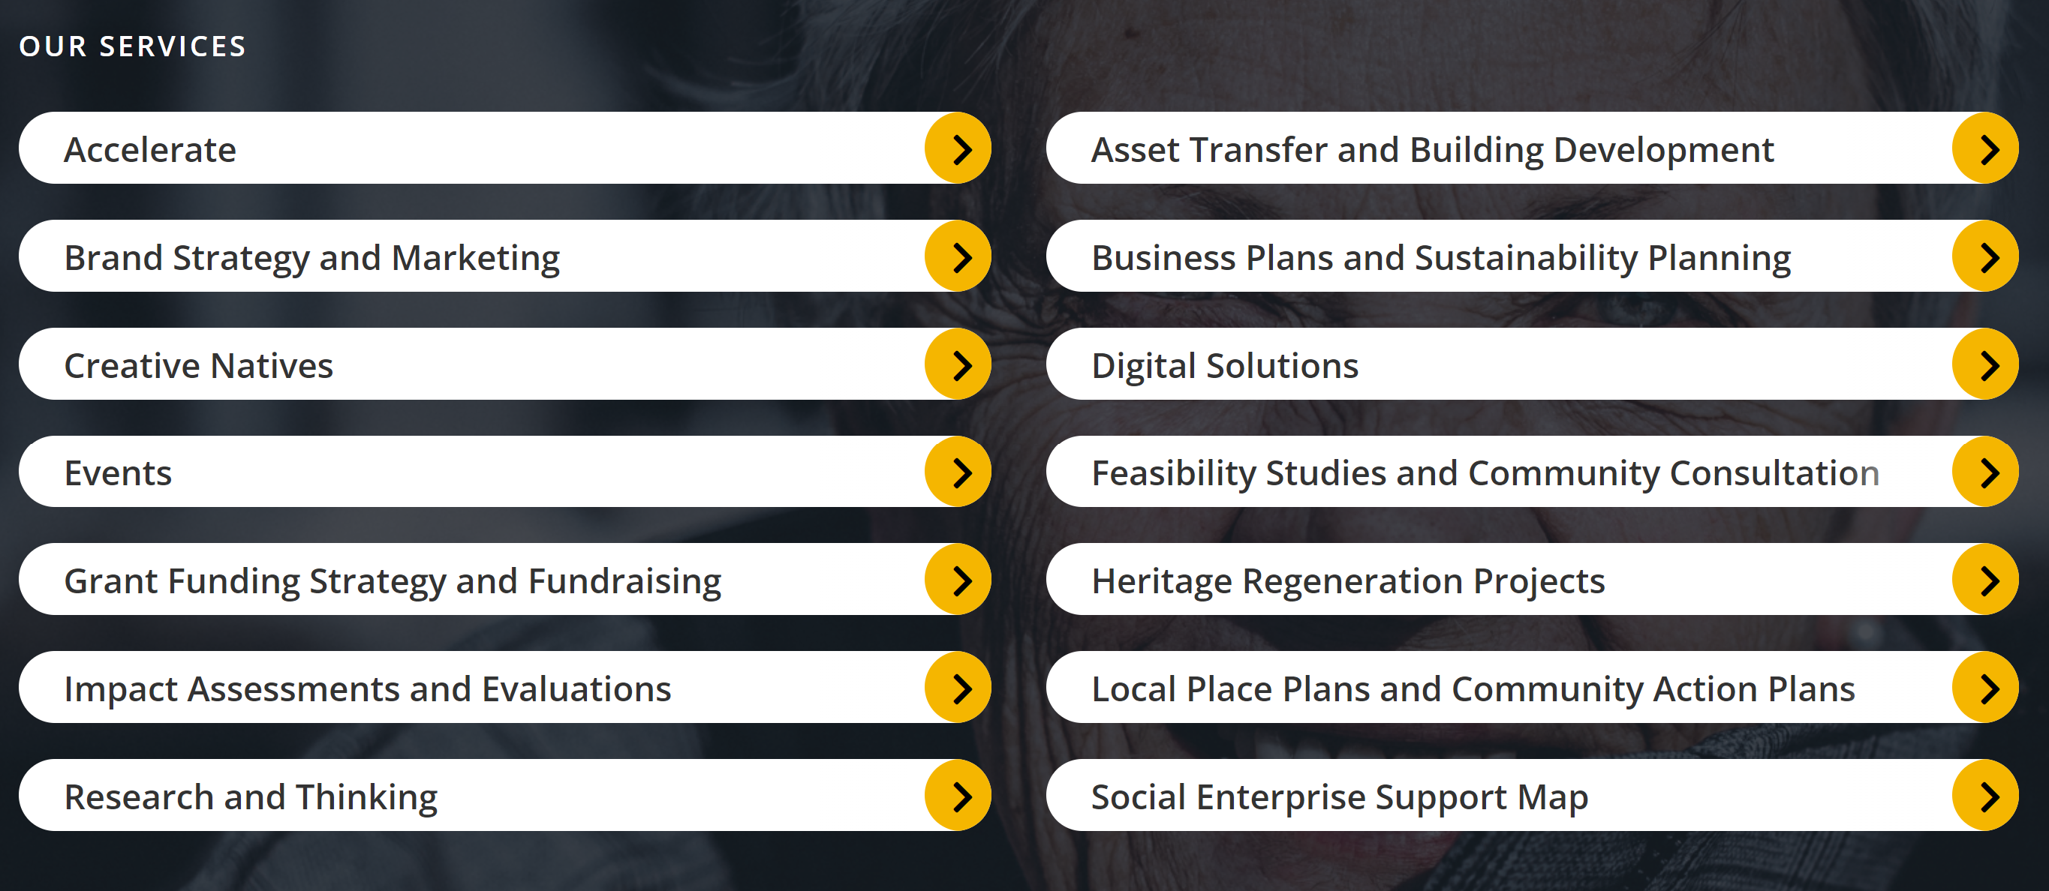

Vision and Mission
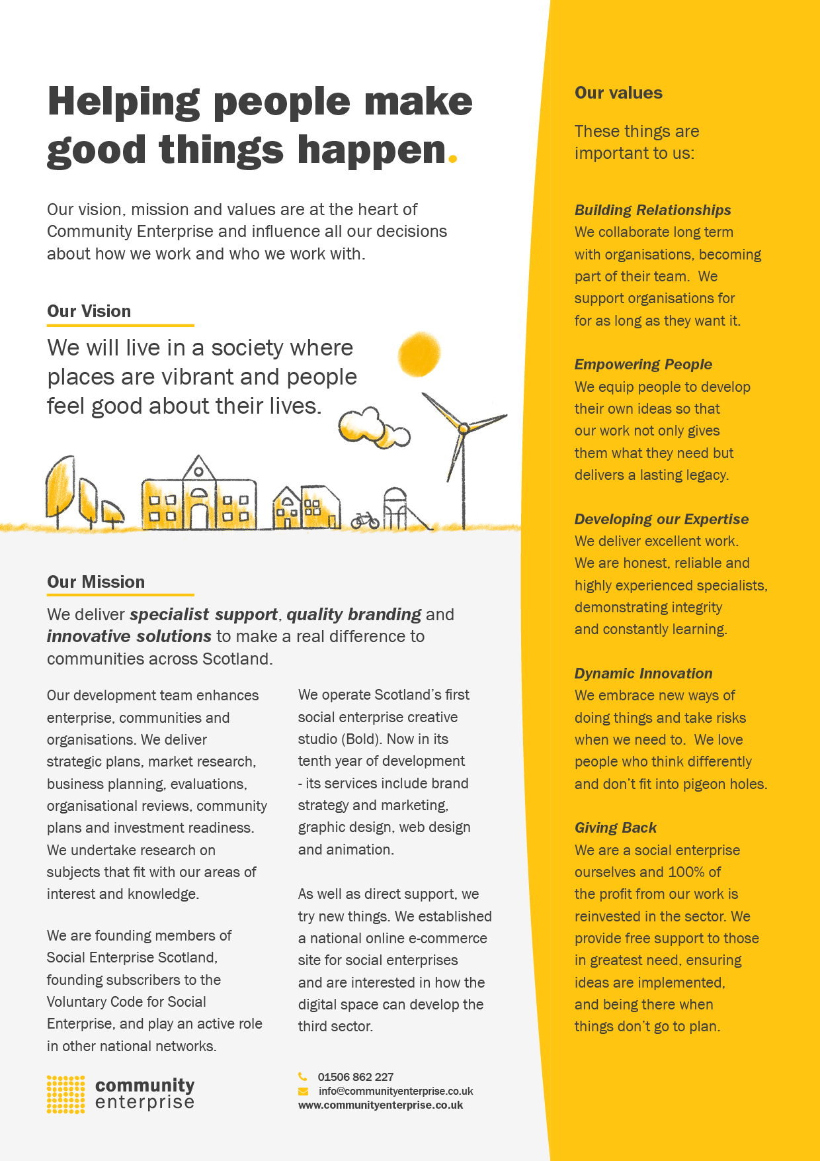
Company Details
Company Structure | Community Enterprise is a company limited by guarantee with charitable status. CEL Trading is a company limited by shares that is a wholly owned subsidiary of Community Enterprise Ltd.
Registered Address | Main office: Suite 12a, Fleming House, Fleming Road Kirkton Campus Livingston EH54 7BN. Our design studio is in Glasgow.
Community Enterprise Ltd | Charity Number : SC006992  Company Number : 107265
CEL Trading Company number | SC142050
Website | www.communityenterprise.co.uk
Twitter | @CommEnterprise
Linkedin | https://www.linkedin.com/company/commenterprise/mycompany/
Accounts | Our accounts can be downloaded from here

Existing board members
Short CVs can be seen here.
1.5 Board commitment
As a Board member of a Community Enterprise and our trading subsidiary, CEL Trading, you have an important and crucial role to play in governing our work, in accordance our company rules and business and operational plans. We have a big vision to make ensure we “live in a society where places are vibrant and people feel good about their lives”. Being a board member of Community Enterprise is a positive and exciting role to change things for the better.
Below you will find a full description of the role of a board member, which includes your legal and statutory obligations. Once settled in, board members can sometimes take on more responsibility (such as office bearer roles – chair, vice chair, treasurer, and secretary etc.) the responsibilities of which are outlined separately. At the end of this document is an expression of interest form for you to send us if you are interested in exploring this further.
Remuneration: Board members are not remunerated but are entitled to claim their out of pocket expenses.
Time Commitment : This is dependent on role with some roles (office bearers) requiring more time, but we do need people who will commit time an energy to this. We are not looking for “seat warmers” but people who are passionate and active for social change in Scotland.
At a minimum, the ordinary board role involves preparing for and attending regular board meetings (usually quarterly), as well as an additional ‘away day’ and short supplementary meetings for specific purposes and decisions. Further contributions of time for working groups are likely. For an ordinary board member we estimate a commitment of around 2 hours per month but for an office bearer this can be a little higher. We have a mix of face to face and online meetings.
1.6. What We Give to you
- The chance to be involved in an organisation at the forefront of Scotland’s regeneration and the development of sustainable communities.
- An opportunity to build your CV that can help your future activities.
- Become part of a team of interesting people with in-depth knowledge of the third sector.
- A way to use the skills and experience you have in a new way.
- The chance to visit other projects, conferences and meetings across Scotland
1.7 Board members …
- Will contribute to, agree with and commit to the organisation’s purpose, vision and mission, and be able to talk about it clearly.
- Will have ultimate responsibility for directing the overall work of Community Enterprise, ensuring it is financially viable, efficiently run, and delivering the outcomes for which it has been set up.
- Will need to be carefully think through decisions and you will need to contribute to and get involved in debate while being able to listen to others.
- Must ensure that the organisation complies with its company rules, relevant laws, and the requirements of any regulatory bodies. The company secretary and CEO can support the board in this.
- Should attend the necessary induction, training and ongoing training and assess the information they get to make good decisions.
- Must regularly review the risks to which Community Enterprise is subject, taking action to mitigate risks identified with the support of the CEO.
- Should ensure that the Board has the best range of skills, experience and knowledge needed to run Community Enterprise effectively. Regular skills audits can help understand what new skills might be needed.
- Should ensure that the Board organises its work to make the most effective use of the time, skills and knowledge of Board members. This should not be a “talking shop”, rather we want a useful board that in turn makes you feel useful.
- Board members agree to assist in making careful decisions and to share responsibility for decisions. Board members agree to respect the final decision of the Board which can be based on a vote where consensus can’t be reached, although this is unlikely.
- Board members should ensure that office bearers are clear about their specific roles
- The board should use the resource they have in the staff team to help them make good decisions – they should work together with the CEO.
Delegation – the roles of staff and board
Board members focus on the strategic direction of Community Enterprise. The Board agree to delegate certain operational matters to paid staff. The board and senior staff therefore work very closely together.
Code Of Conduct
- Board members should contribute respectfully and listen carefully to all in a debate. Board members should contribute to discussions in a relevant and constructive way and conduct themselves with kindness, respecting the authority of the chairperson to direct the meeting.
- Board members should ensure that they apply the principles of equality and diversity, and that Community Enterprise (board, staff, volunteers, beneficiaries and stakeholders) is open to everyone regardless of circumstances or background.
- Board members should prepare fully for Board Meetings and ensure they have read any related papers
- Board members must commit to attend the majority of board meetings (unless prevented by unavoidable circumstances or excused for special reasons). Those unable to attend should convey their apologies to the Chair or Secretary in advance of the meeting. Those not in attendance for three meetings without an apology will be contacted to clarify their continuing board membership.
- Board members must not benefit from their position. Board members agree to complete a declaration of interests form and observe Community Enterprise’s Conflict of Interest Policy.
- Board members have a responsibility to maintain confidentiality of Board papers and discussions unless authorised by the Board to release information.
What To Do If You Are Interested
If you are interested in finding out more, please email bridget@communityenterprise.co.uk who will put you in touch with either the chair or the CEO to have an early conversation.
If you still feel this is for you, please submit an expression of interest. We are recruiting carefully to get the right people and will want to meet you to ensure there is a mutually beneficial fit.

BOARD MEMBER EXPRESSION OF INTEREST FORM
Thank you for expressing interest in becoming a board member of Community Enterprise. Please return this form and we will be in touch to discuss the role.
The form can be found at this link
Name:
Home Address
Phone number
Email address
What attracted you to be interested in joining the Community Enterprise board
Please tell us a little about the skills and experience you would bring to the role. This can include work experience now or in the past, qualifications and bespoke skills, hobbies or skills developed in your family
Do you have any concerns or questions for us
Deadline | 12th January with interviews that week
Once you have completed this form, please email it to bridget@communityenterprise.co.uk or fill it in online here.

Roles Required at the Moment
Role : Treasurer / Finance Expert
Though it is important that all trustees collectively play their part in financial monitoring and decision making, the treasurer has a specific role to oversee the finances by managing budgets and ensuring that there is enough income coming in to meet expenditure. Need to support the staff team during the preparation of year end accounts for the AGM.
Providing financial guidance and mentoring to the senior staff team as they manage the finances of the organisation.
Time commitment: Quarterly board meeting with preparation and additional activity.
Leading a finance sub-group and meeting with senior staff every 6 weeks.
Skills and Experience : Though a chartered accountant would be an advantage we would welcome those with in depth financial management and financial systems knowledge and experience.
Role : Digital
To support the work of Breeze, our digital division, we want to recruit a digital expert who may come from outwith the third and social enterprise sector but who can bring expertise to help the board to manage our new Digital agency.
Time Commitment : Quarterly board meeting with preparation and additional activity meeting the Breeze team between board meetings.
Skills and Experience : Someone who is an all-rounder with a good knowledge of the digital world and how it impacts on the third sector, rather than someone with a single issue skill set.
Role : Marketing and Branding
Bold, our branding and design agency, has been part of the Community Enterprise family for 12 years but don’t have anyone at board level who has an overview of that part of the business. We are particularly interested in securing an individual with in-depth knowledge of branding and brand strategy, design and campaigning.
Time Commitment : Quarterly board meeting with preparation and additional activity meeting the Bold team between board meetings.
Skills and Experience : A strong working knowledge of how design agencies work.

